C:\Documents and Settings\tperry\Local Settings\Temporary Internet Files\Content.IE5\5U9BXN0B\MC900304849[1].wmf

###### McCamon-Hunt Insurance Agency Inc, 8150 Market St. Boardman, OH 44512

###### Mccamonhunt.com   rhartford@mccamonhunt.com   330-726-8850

*Office Hours: Monday-Friday 8:30a.m.-5:00p.m. or by appointment*

McCamon-Hunt

Newsletter

December 2011

Volume 1, Issue 1

**Visit us online at mccamonhunt.com**

**-Or-**

**Like us on Facebook**

# **Flood Reminder**

We have also received questions pertaining to flood insurance. This is a reminder that Homeowners policies typically do not cover damages from flood water. To ensure coverage in the event of a flood, a separate flood insurance policy must be purchased. Please contact our office if you are interested in obtaining a flood quote for your residence.

# Happy Holidays

We here at McCamon-Hunt would like thank you for another year of your business and wish you all a safe, happy holiday season and a great new year.

# **Send Us Your E-mail**

Here at McCamon-Hunt, we are always trying to find ways to better serve our customers. We have recently created a Facebook page to make connecting with customers easier. We are also in the process of updating our client information. In order to accurately update our current files we are asking that all of our customers please give us a current e-mail address so we can modernize our database, making it easier to contact you with important information. Please send an e-mail to [rhartford@mccamonhunt.com](mailto:rhartford@mccamonhunt.com) containing your first and last names or like us on Facebook at facebook.com/mccamonhunt and send us a message including your e-mail address.

**“Homeowners policies typically do not cover damages caused by flood water.”**

**“most policies we sell do not cover earthquake damages; however, earthquake coverage can be endorsed.”**

Due to our area’s recent seismic activity, we have received numerous questions concerning the covered damages in the event of an earthquake. We would like to inform you that most polices we sell do not cover earthquake damages; however, earthquake coverage can be endorsed. For more information on the earthquake endorsement call the office at (330)726-8850 during business hours or visit us online anytime at mccamonhunt.com.

# **Earthquake Coverage**

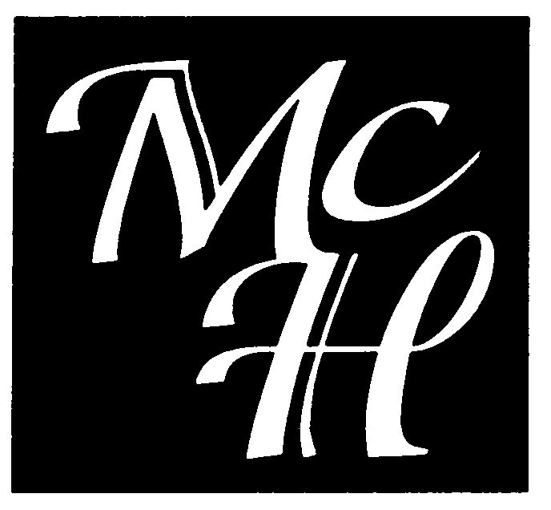

By Author Name